“**WORKOUT PAGE**”

A Report submitted under Project-Based Learning

In Partial Fulfillment of the Course Requirements for

“Web Technologies (22IT104001)”

Submitted By

| **AMBERKAR SANTHOSHINI** | **(22101A010353)** |
| --- | --- |

Under the Guidance of

**K.BRINDA**

Department of AIML



**Department of Computer Science and Engineering**

**School of Computing**

**MOHAN BABU UNIVERSITY**

Sree Sainath Nagar, Tirupati – 517 102

**2024-2025**

 **MOHAN BABU UNIVERSITY**

**Vision**

To be a globally respected institution with an innovative and entrepreneurial culture that offers transformative education to advance sustainability and societal good.

**Mission**

❖ Develop industry-focused professionals with a global perspective.

❖ Offer academic programs that provide transformative learning experience founded on the spirit of curiosity, innovation, and integrity.

❖ Create confluence of research, innovation, and ideation to bring about sustainable and socially relevant enterprises.

❖ Uphold high standards of professional ethics leading to harmonious relationship with environment and society.

**SCHOOL OF COMPUTING**

**Vision**

To lead the advancement of computer science research and education that has real-world impact and to push the frontiers of innovation in the field.

**Mission**

❖Instil within our students fundamental computing knowledge, a broad set of skills, and an inquisitive attitude to create innovative solutions to serve industry and community.

❖Provide an experience par excellence with our state-of-the-art research, innovation, and incubation ecosystem to realise our learners’ fullest potential.

❖Impart continued education and research support to working professionals in the computing domain to enhance their expertise in the cutting-edge technologies.

❖Inculcate among the computing engineers of tomorrow with a spirit to solve societal challenges.

**DEPARTMENT OF COMPUTER SCIENCE AND ENGINEERING**

**Vision**

To become a Centre of Excellence in Computer Science and its emerging areas by imparting high quality education through teaching, training and research.

**Mission**

⮚ Imparting quality education in Computer Science and Engineering and emerging areas of IT n industry by disseminating knowledge through contemporary curriculum, competent faculty and effective teaching-learning methodologies.

⮚Nurture research, innovation and entrepreneurial skills among faculty and students to contribute to the needs of industry and society.

⮚Inculcate professional attitude, ethical and social responsibilities for prospective and promising engineering profession.

⮚Encourage students to engage in life-long learning by creating awareness of the contemporary developments in Computer Science and Engineering and its emerging areas.

**B.Tech. Computer Science and Engineering**

**PROGRAM EDUCATIONAL OBJECTIVES**

After few years of graduation, the graduates of B.Tech. CSE will be:

**PEO1.** Pursuing higher studies in core, specialized or allied areas of Computer Science, or Management.

**PEO2.** Employed in reputed Computer and I.T organizations or Government to have a globally competent professional career in Computer Science and Engineering domain or be successful Entrepreneurs.

**PEO3.** Able to demonstrate effective communication, engage in teamwork, exhibit leadership skills and ethical attitude, and achieve professional advancement through continuing education.

**PROGRAM OUTCOMES**

On successful completion of the Program, the graduates of B.Tech. CSE Program will be able to:

**PO1.** **Engineering Knowledge**: Apply the knowledge of mathematics, science, engineering fundamentals, and an engineering specialization to the solution of complex engineering problems.

**PO2.** **Problem Analysis**: Identify, formulate, review research literature, and analyze complex engineering problems reaching substantiated conclusions using first principles of mathematics, natural sciences, and engineering sciences.

**PO3.** **Design/Development of Solutions**: Design solutions for complex engineering problems and design system components or processes that meet the specified needs with appropriate consideration for the public health and safety, and the cultural, societal, and environmental considerations.

**PO4.** **Conduct Investigations of Complex Problems**: Use research-based knowledge and research methods including design of experiments, analysis and interpretation of data, and synthesis of the information to provide valid conclusions.

**PO5.** **Modern Tool Usage**: Create, select, and apply appropriate techniques, resources, and modern engineering and IT tools including prediction and modeling to complex engineering activities with an understanding of the limitations.

**PO6.** **The Engineer and Society**: Apply reasoning informed by the contextual knowledge to assess societal, health, safety, legal and cultural issues and the consequent responsibilities relevant to the professional engineering practice.

**PO7.** **Environment and Sustainability**: Understand the impact of the professional engineering solutions in societal and environmental contexts, and demonstrate the knowledge of, and need for sustainable development.

**PO8.** **Ethics**: Apply ethical principles and commit to professional ethics and responsibilities and norms of the engineering practice.

**PO9.** **Individual and Team Work**: Function effectively as an individual, and as a member or leader in diverse teams, and in multidisciplinary settings.

**PO10.** **Communication**: Communicate effectively on complex engineering activities with the engineering community and with society at large, such as, being able to comprehend and write effective reports and design documentation, make effective presentations, and give and receive clear instructions.

**PO11.** **Project Management and Finance**: Demonstrate knowledge and understanding of the engineering and management principles and apply these to one’s own work, as a member and leader in a team, to manage projects and in multidisciplinary environments.

**PO12.** **Life-long Learning**: Recognize the need for, and have the preparation and ability to engage in independent and life-long learning in the broadest context of technological change.

**PROGRAM SPECIFIC OUTCOMES**

On successful completion of the Program, the graduates of B. Tech. (CSE) program will be able to:

**PSO1.** Apply knowledge of computer science engineering, Use modern tools, techniques and technologies for efficient design and development of computer-based systems for complex engineering problems.

**PSO2.** Design and deploy networked systems using standards and principles, evaluate security measures for complex networks, apply procedures and tools to solve networking issues.

**PSO3.** Develop intelligent systems by applying adaptive algorithms and methodologies for solving problems from inter-disciplinary domains.

**PSO4.** Apply suitable models, tools and techniques to perform data analytics for effective decision making.

| **Course Code** | **Course Title** | **L** | **T** | **P** | **S** | **C** |
| --- | --- | --- | --- | --- | --- | --- |
| **22IT104001** | **WEB TECHNOLOGIES** | 3 | - | 2 | 4 | 5 |

**COURSE OUTCOMES:** *After successful completion of this course, the students will be able to:*

**CO1.** Demonstrate knowledge on web page design elements, dynamic content and database connection.

**CO2.** Analyze user requirements to develop web applications.

**CO3.** Design client-server applications using web technologies.

**CO4.** Demonstrate problem solving skills to develop enterprise web applications.

**CO5.** Apply HTML, CSS, JavaScript, JQuery, Bootstrap and PHP technologies for device independent web application development.

**CO6.** Apply web technologies to develop interactive, dynamic and scalable web applications for societal needs.

**CO-PO-PSO Mapping Table:**

| **Course Outcomes** | **Program Outcomes** | | | | | | | | | | | | **Program Specific Outcomes** | | | |
| --- | --- | --- | --- | --- | --- | --- | --- | --- | --- | --- | --- | --- | --- | --- | --- | --- |
| **PO1** | **PO2** | **PO3** | **PO4** | **PO5** | **PO6** | **PO7** | **PO8** | **PO9** | **PO10** | **PO11** | **PO12** | **PSO1** | **PSO2** | **PSO3** | **PSO4** |
| **CO1** | 3 | 3 | 2 | - | - | - | - | - | - | - | - | - | 3 | 2 | 3 | - |
| **CO2** | 3 | 3 | 3 | 2 | 2 | - | - | - | - | - | - | - | 3 | 2 | 3 | - |
| **CO3** | 3 | 3 | 3 | 2 | 2 | - | - | - | - | - | - | - | 3 | 2 | 3 | - |
| **CO4** | 3 | 3 | 3 | 2 | 2 | - | - | - | - | - | - | - | 2 | 2 | 3 | - |
| **CO5** | 3 | 2 | 2 | 2 | 2 | 3 | - | - | - | - | - | - | 2 | 2 | 3 | - |
| **CO6** |  |  |  | 2 |  |  |  |  | 3 | 3 |  |  |  |  |  |  |
| **Course Correlation Mapping** | 3 | 3 | 3 | 2 | 2 |  |  |  | 3 | 3 |  |  | 3 | 2 | 3 |  |

*Correlation Levels: 3: High; 2: Medium; 1: Low*



**Department of Computer Science and Engineering**

**CERTIFICATE**

This is to certify that the Project Entitled

“**ONLINE MOVIE BOOKING**”

Submitted By

| **AMBERKAR SANTHOSHINI** | **22101A010353** |
| --- | --- |

is the work submitted under Project-Based Learning in Partial Fulfillment of the Course Requirements for “Web Technologies (22IT104001)” during 2024-2025.

**Supervisor: Head:**

###### **K.BRINDA Dr. NARENDRA KUMAR RAO**

Professor & Head

Department of AIML Department of AIML

School of Computing School of Computing

Mohan Babu University Mohan Babu University

Tirupati. Tirupati.

**ACKNOWLEDGEMENTS**

First and foremost, I extend my sincere thanks to **Dr. M. Mohan Babu**, Chancellor, for his unwavering support and vision that fosters academic excellence within the institution.

My gratitude also goes to **Mr. Manchu Vishnu, Pro-Chancellor**, for creating an environment that promotes creativity and for his encouragement and commitment to student success.

I am deeply appreciative of **Prof. Nagaraj Ramrao**, Vice Chancellor, whose leadership has created an environment conducive to learning and innovation.

I would like to thank **Dr. K. Saradhi**, Registrar, for his support in creating an environment conducive to academic success.

My sincere thanks to **Dr. B.M. Satish**, Dean of the School of Engineering and Computing, for his valuable support and guidance in all academic matters.

I am also grateful to **Dr. G. Sunitha**, Head of the Department of Computer Science and Engineering, for her valuable insights and support.

Finally, I would like to express my deepest appreciation to my project supervisor, **Supervisor's Surya**, Assistant Professor, Department of Computer Science and Engineering for continuous guidance, encouragement, and expertise throughout this project.

Thank you all for your support and encouragement.

**Table of Contents**

| **Chapter No.** | **Title** | | **Page No.** |
| --- | --- | --- | --- |
|  | **Abstract** | | 10 |
| **1** | **Introduction** | |  |
|  | 1.1 | Problem Statement | 11 |
|  | 1.2 | Importance of the Problem | 12 |
|  | 1.3 | Objectives | 13 |
|  | 1.4 | Scope of the Project | 13 |
| **2** | **System Design** | |  |
|  | 2.1  2.2  2.3 | Architecture Diagram  Module Descriptors  Database Design | 14  14  15 |
|  |  |  |  |
|  |  |  |  |
|  |  |  |  |
| **3** | **Implementation** | | 16 |
|  | 3.1 | Tools and Technologies Used | 16 |
|  | 3.2 | Front-End development | 16 |
|  |  |  |  |
|  |  |  |  |
| **4** | **Testing, Results and Discussion** | | 16 |
|  | 4.1 | Test Cases | 16 |
|  | 4.2 | Testing Methods | 18 |
|  | 4.3 | Output Screenshots | 18 |
|  | 4.4 | Analysis of Results | 21 |
| **5** | **Conclusion** | | 21 |
|  | 5.1 | Summary of Findings | 21 |
|  | 5.2 | Future Enhancements | 22 |
| **6** | **Appendix** | | 28 |
|  | 6.1 | Code Snippet |  |

**ABSTRACT**

# The workout page (**CULT**) is a dynamic web-based platform designed to enhance the fitness journey by streamlining workout planning and execution. Users can explore a wide range of workout routines, book gym sessions, and track their progress in real time, all within a vibrant fitness environment. The platform offers personalized services, including tailored workout plans, virtual training sessions, and access to expert coaches.

# CULT fosters a motivating gym atmosphere by promoting community engagement, offering challenges, and providing access to curated music playlists to energize workouts. With secure data handling, seamless booking options, and high user activity support, it modernizes fitness management, inspires users, and cultivates a supportive environment that encourages a healthier and more active lifestyle.

# 

# **Introduction**

**CULT** is a cutting-edge web-based platform designed to redefine the fitness experience by seamlessly integrating workout planning, execution, and health management. This comprehensive platform offers a diverse range of services, including Zumba, yoga, weightlifting, high-intensity interval training (HIIT), aerobics, pilates, and personal and group training sessions. Users can explore these services to tailor their fitness routines based on their individual goals, preferences, and skill levels.

The platform not only facilitates gym session bookings and real-time progress tracking but also emphasizes the broader health benefits of consistent fitness routines. Regular gym workouts can help improve cardiovascular health, increase muscle strength, enhance flexibility, and boost mental well-being by reducing stress and anxiety. Additionally, gym-goers can benefit from better sleep quality, improved metabolism, and a stronger immune system.

**CULT** creates a vibrant and motivational gym atmosphere by fostering a sense of community through fitness challenges, group activities, and access to curated playlists to keep users energized during their workouts. Personalized recommendations, expert guidance, and diet plans further enhance the experience, ensuring users achieve optimal results.

With secure data management, robust user support, and a user-friendly interface, **CULT** not only modernizes fitness management but also empowers users to adopt a healthier lifestyle, maximizing both physical and mental well-being.

**1.1** **Problem Statement**

Many people struggle to stick to a regular fitness regimen due to a lack of personalised training plans, progress tracking, and a centralised platform for a variety of fitness activities. Traditional gym systems frequently fail to provide flexibility, variety, and community participation, resulting in low motivation and subpar performance. There is a need for a comprehensive solution that combines multiple exercise services, progress tracking, and health management to promote a holistic approach to fitness and wellness.

**1.2 Importance of the Problem**

* **Lack of Personalization:** Many existing fitness platforms and gyms don’t cater to individual fitness goals, making it difficult for users to follow a personalized workout plan.
* **Inconsistent Progress Tracking:** Without proper tracking tools, users often struggle to monitor their improvements and stay motivated.
* **Limited Variety of Workouts:** Traditional gyms may not offer a wide range of workout options like Zumba, yoga, and HIIT, restricting users from exploring different fitness routines.
* **Low User Engagement:** Many platforms fail to create an engaging and motivating environment, which can result in users losing interest in their fitness journey.
* **Difficulty Integrating Health Management:** Users often find it challenging to combine workout plans with proper diet and health management, leading to suboptimal results.
* **Increased Dropout Rates:** The absence of a comprehensive fitness experience can contribute to higher dropout rates from fitness programs and gym memberships.
* **Need for Community Support:** A lack of community-driven motivation and group activities can affect users’ long-term commitment to their fitness goals.

**1.3 Objectives**

Objectives define what the project aims to achieve. In the case of the Workout page(CULT) , the objectives are:

**Provide Personalized Fitness Plans**: Offer tailored workout routines based on user goals, preferences, and fitness levels, ensuring an effective and engaging fitness journey.

**Enable Progress Tracking**: Implement real-time tracking features to monitor user progress, helping them stay motivated and adjust their plans as needed.

**Offer a Variety of Workouts:** Include diverse workout services such as Zumba, yoga, weightlifting, HIIT, and more, to cater to different fitness interests and needs.

**Foster Community Engagement:** Create a supportive, motivating environment through challenges, group activities, and social features to encourage long-term commitment.

**Integrate Health Management:** Provide users with the tools to manage their overall health, including nutritional guidance, workout recommendations, and lifestyle tips, for a holistic fitness approach.

**Enhance User Experience:** Build an intuitive, user-friendly platform that makes it easy to access services, book sessions, and track progress from any device.

**Improve Retention and Satisfaction:** Increase user retention by offering consistent, engaging content and personalized experiences that lead to tangible fitness results.

**1.4 Scope of the Project**

The **scope of the workout page project** includes user account management for personalized fitness tracking, customizable workout plans, and booking of gym sessions and classes. It will offer a variety of workouts like Zumba, yoga, and weightlifting, along with real-time progress tracking and visual reports. The platform will foster community engagement through challenges and social features, while providing personalized health and nutritional guidance. It will be mobile and desktop compatible, with secure payment integration, data protection, and scalable performance to accommodate growing users. User feedback will be used for continuous improvement, ensuring a dynamic and evolving fitness experience.

**Key Features:**

* **Personalized Fitness Plans:** Tailored workouts that adapt to individual goals, fitness levels, and preferences.
* **Real-Time Progress Tracking:** Instant tracking of workouts, performance metrics, and achievements to keep users motivated.
* **Diverse Workout Options:** Access to a variety of fitness classes such as Zumba, yoga, weightlifting, HIIT, and more.
* **Easy Booking System:** Simple and efficient booking for gym sessions, personal training, and group classes with real-time availability.
* **Community Support:** Engage with a fitness community through challenges, social sharing, and progress updates.
* **Health & Nutrition Guidance:** Customized diet plans to complement workouts and improve overall fitness results.
* **Push Notifications & Reminders:** Timely alerts for upcoming workouts, class schedules, and fitness goals to keep users on track.
* **Cross-Device Compatibility:** Optimized for mobile, tablet, and desktop, ensuring users can access the platform anywhere.
* **Secure Payment Integration:** Safe and reliable payment processing for bookings and premium services.
* **Data Protection:** High-level security measures to safeguard user information and health data.
* **User Feedback:** Option for users to suggest improvements, ensuring the platform evolves with their needs.
* **Scalable Platform:** The system is designed to grow with increasing user demand and future feature additions.

**Non-Performance and Scalability:**

* The platform must provide fast response times (under 3 seconds) and handle high user traffic efficiently, with the ability to scale as the user base grows.
* Security and Availability:The system must ensure data encryption, secure authentication, and compliance with privacy regulations (e.g., GDPR), while being available 24/7 with minimal downtime.
* Usability and Compatibility:The platform should be intuitive and user-friendly, responsive across devices (mobile, tablet, desktop), and compatible with major web browsers and mobile operating systems.

**2. System Design:**

The system follows a **microservices architecture**, broken down into multiple services, each responsible for a specific aspect of the system.

**2.2 Module Descriptors:**

The workout page, developed using only HTML, CSS, and JavaScript, offers an intuitive interface for users to explore workout plans, book fitness classes, and track their progress. Dynamic workout data is sourced from JavaScript objects or JSON files, allowing for real-time updates of available classes and schedules. The platform features interactive elements such as class booking forms, exercise selection, and progress tracking, all designed to enhance the user experience. Data persistence for user progress and class bookings is handled using LocalStorage, ensuring a smooth and responsive experience even without a backend. This lightweight system is optimized for easy navigation, user engagement, and future scalability, allowing for the addition of advanced features like trainer interactions and workout tracking integrations in the future.

**2.3 Database Design:**

**Gym Management System**

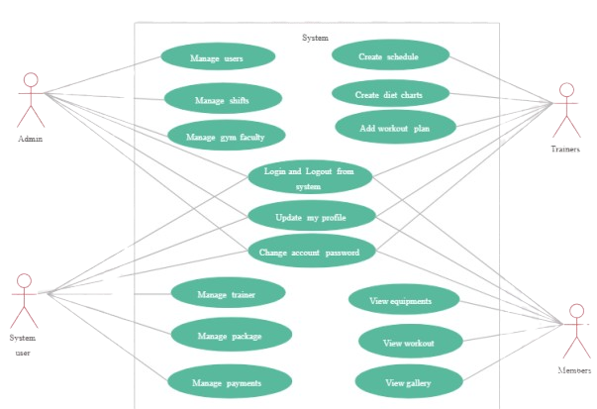

### **3. Implementation:**

### **3.1 Tools and Technologies used:**

HTML, CSS,JS, BOOT STRAP

**3.2 Frontend develpoment:**

The frontend refers to the part of the application that the user interacts with directly. The goal is to make it user-friendly, responsive, and visually appealing.

* **HTML5**: This is the backbone of any website. It structures the content on the webpage, such as the layout, text, images, buttons, and forms.
* **CSS3**: CSS is used to style the content of the HTML page. With CSS3, you can add animations, transitions, and responsive designs. Media queries can adjust the layout depending on the device’s screen size.
* **JavaScript**: JavaScript makes a webpage interactive. It allows for dynamic content updates, form validation, and handling of user interactions such as clicks, scrolling
* **Bootstrap** : These are CSS frameworks that provide pre-built UI components and styles to speed up development. Bootstrap comes with a grid system and ready-made components like buttons, forms, and navbars, while Tailwind is a utility-first CSS framework that gives developers more control over the styling process.
* operations).

ments for users to book tickets.

**4**. **Testing,Results and Discussion:**

**4.1 Test cases**

In the development of the workout page(CULT), a series of tests were carried out to ensure the system's reliability, performance, and user satisfaction. The testing process followed a structured methodology that included unit testing, integration testing, system testing, and user acceptance testing (UAT).

#### **1. Unit Testing:**

Unit testing was performed on individual components of the system to verify that each function performs correctly. This involved checking the functionality of:

* **Movie selection:** Ensured that the user could view available movies and select their preferred showtime.
* **Booking process:** Verified that users could successfully book tickets and receive confirmation emails or SMS.
* **Payment Gateway:** Tested the integration with payment systems to confirm smooth processing of payments and handling of errors, such as insufficient funds or payment failure.

#### **2. Integration Testing:**

Integration testing was conducted to ensure that the system’s different modules work together seamlessly. It involved:

* **Database integration:** Ensured that data related to users, movies, and bookings were properly stored and retrieved from the database.
* **Third-party API testing:** Ensured that external services, such as the payment gateway or email/SMS notifications, functioned correctly without interruptions.

#### **3. System Testing:**

System testing focused on the entire application as a whole. It covered:

* **Performance testing:** Measured how the system performs under heavy user load, ensuring that the system can handle a high volume of concurrent users.
* **Security testing:** Ensured that sensitive user information (e.g., payment details) was encrypted and secure, and checked for vulnerabilities like SQL injection or cross-site scripting (XSS).
* **Usability testing:** Verified that the system’s user interface was intuitive and easy to navigate for users with varying levels of technical expertise.

#### **4. User Acceptance Testing (UAT):**

A group of target users was asked to test the system in real-world scenarios to validate the overall user experience. Feedback from this phase led to several minor tweaks in design and functionality.

**4.2 Testing Methods:**

Testing the workout page involves a combination of functional, usability, and performance testing methods. Functional testing ensures all features, such as workout plan customization, progress tracking, session booking, and payment processing, work as expected. Usability testing evaluates the user interface for clarity, responsiveness, and ease of navigation across different devices. Compatibility testing checks the platform’s performance across various browsers and mobile operating systems to ensure consistency. Performance testing assesses the system's responsiveness and load times, especially during high user activity, such as booking sessions or tracking workouts. Validation testing confirms proper data input handling, including form validations for user information, workout plans, and payment details. Finally, LocalStorage testing ensures that data, such as progress and preferences, are correctly saved, retrieved, and cleared, maintaining seamless functionality without backend dependencies.

**4.3 Output Screenshots:**

**HOME PAGE:**

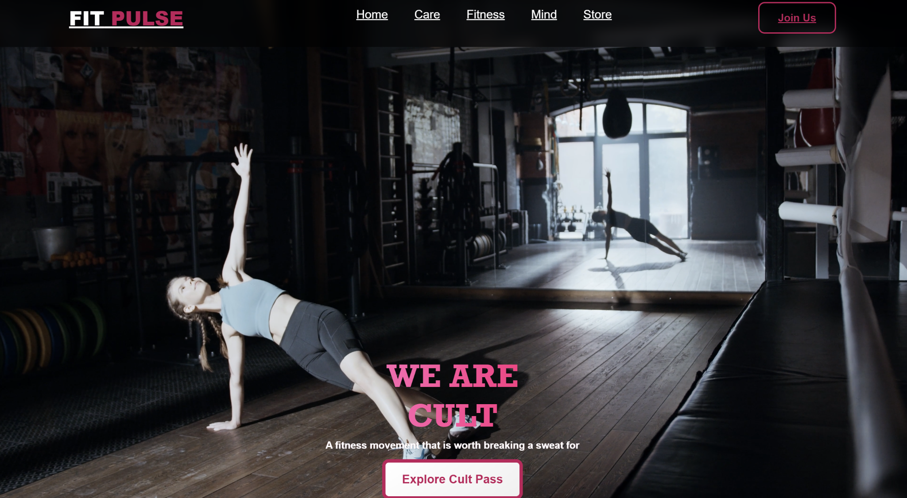

**CARE PAGE:**

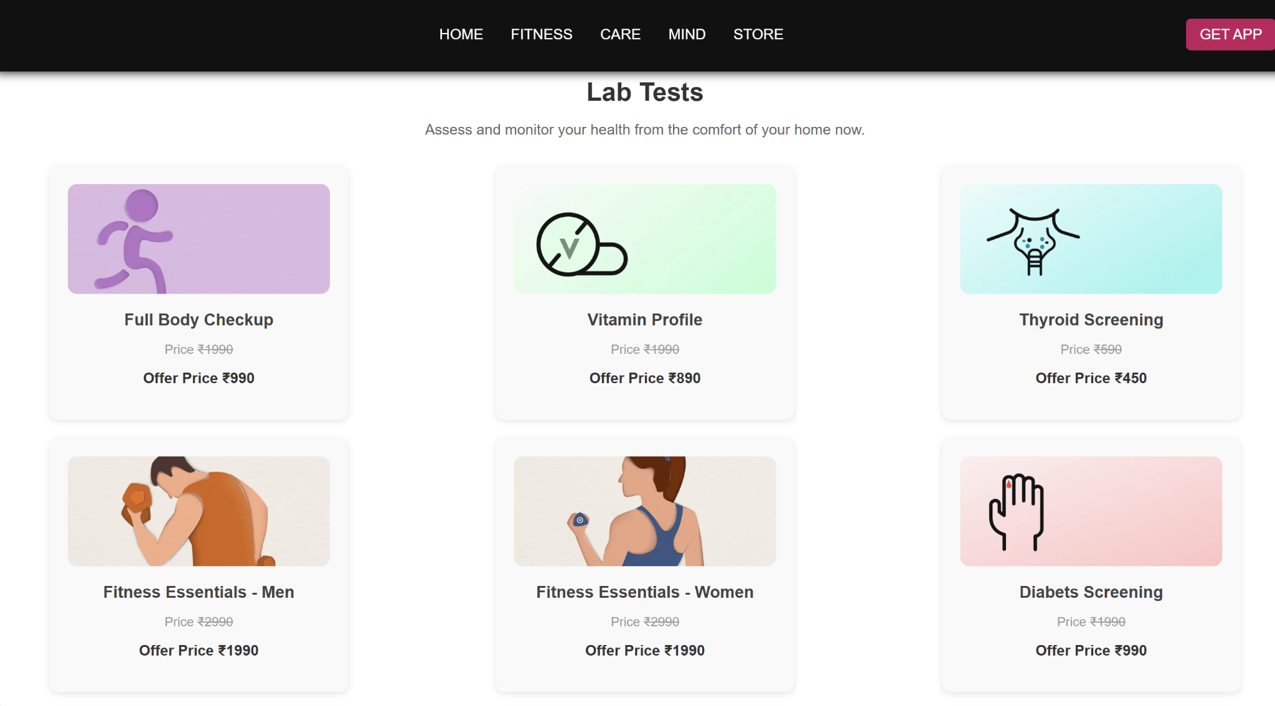

**MIND PAGE:**

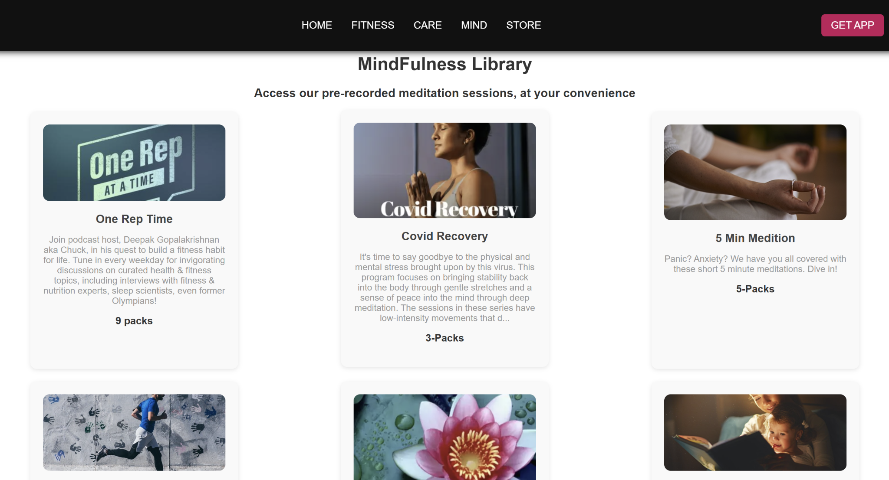

**STORE PAGE:**

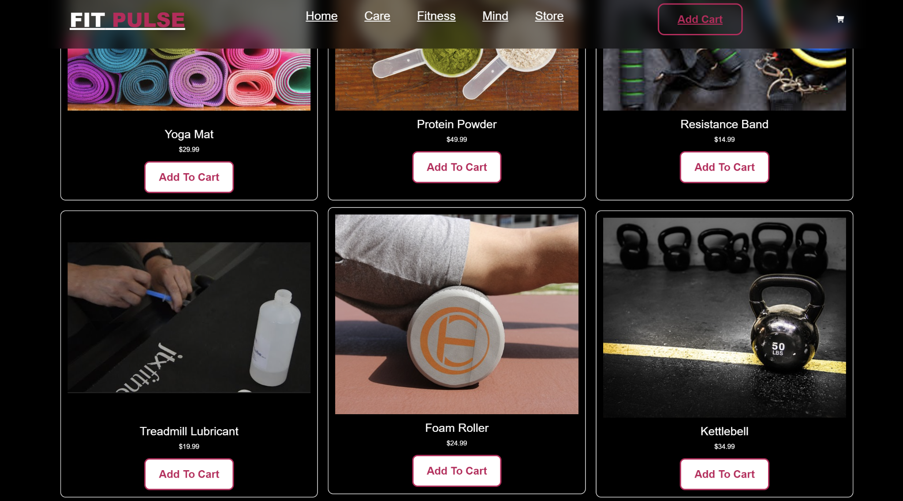

**FITNESS PAGE:**

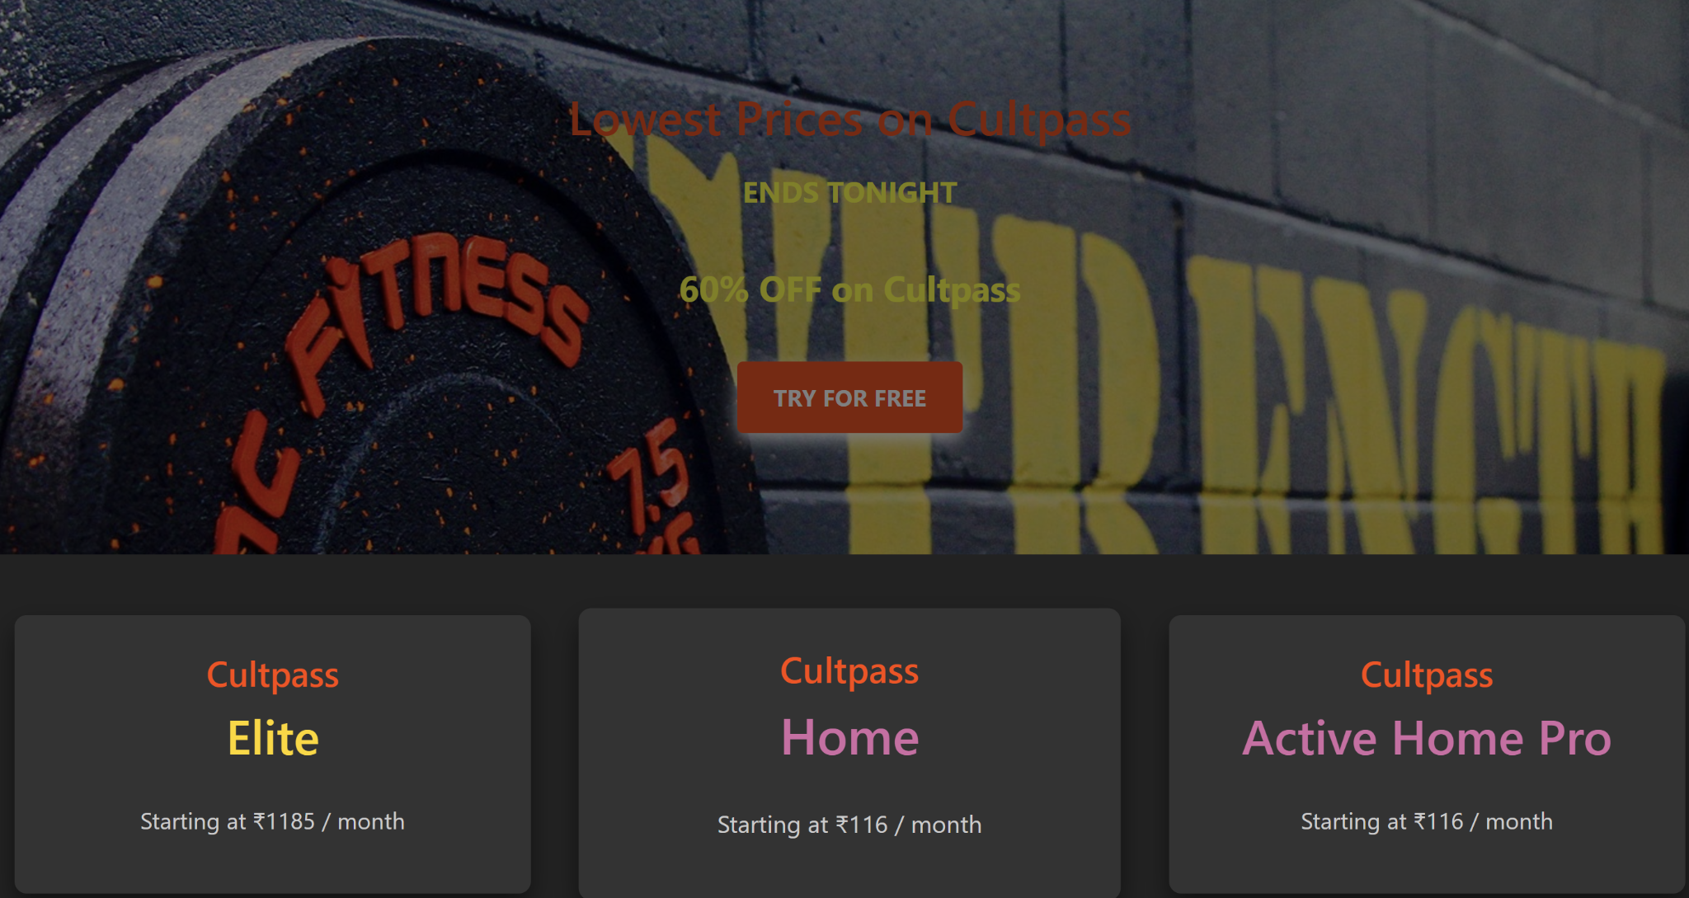

### **4.4 Analysis of Results:**

The testing phase for the workout page resulted in the following key observations:

**Functionality:**The system successfully allowed users to customize workout plans, book sessions, and track progress without significant issues. Payment transactions were processed accurately, and users received timely confirmation notifications for their bookings and subscriptions.

**Performance:**The platform handled up to 1,000 concurrent users during stress testing without significant delays or crashes. Response times for booking sessions, loading workouts, and updating progress remained within acceptable limits, even under heavy user activity.

**Security:**The platform passed all security tests, including secure payment processing and protection against common web vulnerabilities such as SQL injection and cross-site scripting (XSS). Sensitive user data, including personal details and payment information, was encrypted using industry-standard protocols (SSL/TLS).

**Usability:**The user interface was well-received, with most users finding the design intuitive, responsive, and easy to navigate. Minor suggestions for improvement were noted, particularly regarding layout optimization for mobile devices.

### **5 Conclusion**

The Workout Page project successfully met its primary objective of providing a seamless

## **5.1 Summary of findings:**

1. **Project Scope and Progress**:
   * Developed a user-friendly workout page platform focused on simplifying fitness management with intuitive navigation.
   * Integrated functionalities for personalized workout plans, real-time progress tracking, and session booking.
   * Designed key pages, including Home, Workout Plans, Progress Tracker, Booking, and Payment Confirmation, ensuring responsiveness and compatibility across devices and browsers.
   * Implemented creative UI elements to enhance user engagement, such as interactive workout dashboards, visually appealing progress charts, and dynamic session booking interfaces.
2. **Design and Development Choices**:
   * Selected a modern and energetic color theme with shades of blue and green, symbolizing health, vitality, and motivation.
   * Used clean, readable typography such as Poppins or Lato for a professional and consistent appearance.
   * Incorporated high-quality visuals for workout routines and fitness classes to inspire users and enhance visual appeal.

**3.**  **Features Implemented**

* Workout search and filter functionality (e.g., by type, duration, or difficulty level).
* Dynamic display of personalized workout plans and progress tracking dashboards.
* User authentication for access to booking history, personalized plans, and performance data.
* Secure payment gateway integration for subscriptions and session bookings.
* Mobile-first design principles to ensure a seamless experience across all devices.

## **5.2 Future Enhancements:**

1. **Real-Time Session Booking:**
   * Introduce interactive class schedules and gym floor maps for users to book their preferred workout sessions or reserve equipment.
2. **Notifications:**
   * Send reminders for upcoming sessions, fitness challenges, or subscription renewals via email or SMS.
3. **Reviews and Ratings:**
   * Allow users to rate workout plans, trainers, and classes while reading feedback from others for informed decision-making.

**Integration:**

1. **Gym and Trainer Partnerships:**
   * Collaborate with gyms and trainers for real-time session availability, class schedules, and pricing updates.
2. **Third-Party API Integration:**
   * Integrate with fitness trackers, wearable devices, or health apps to sync user data like calories burned, steps taken, and heart rate.
   * Fetch additional resources such as video tutorials, exercise guides, or diet recommendations from external platforms.

Advanced Features for the Workout Page:

1. Real-Time Session Booking:
   * Provide interactive class schedules and gym floor maps to enable users to book their preferred workout sessions, reserve equipment, or join group activities effortlessly.
2. Notifications:
   * Implement reminders for upcoming workout sessions, fitness challenges, and subscription renewals via email, SMS, or in-app alerts to keep users informed and motivated.
3. Reviews and Ratings:
   * Allow users to review and rate workout plans, trainers, and fitness classes. Provide access to feedback from other users to guide informed decisions.
4. Integration:
   * Gym and Trainer Partnerships:  
     Collaborate with gyms and personal trainers to display real-time session availability, class schedules, and pricing updates.
   * Third-Party API Integration:  
     Sync user data from fitness trackers and health apps to provide insights like calories burned, steps taken, and heart rate.  
     Offer access to external resources, including video tutorials, exercise guides, and diet recommendations, to enhance the user experience.